Aloha Hawaii!
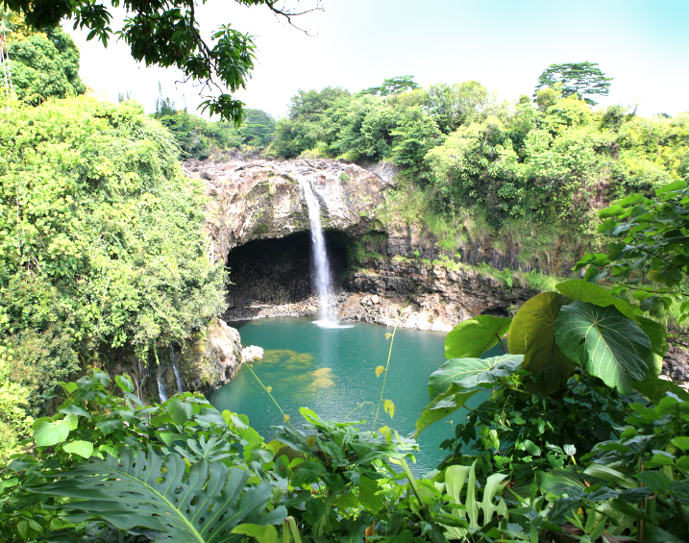
A 10 day adventure trip to the Big Island!
June 24th-July 3rd

Activities include:
Hiking ∙ Waterfalls ∙ Black Sand Beaches ∙ Snorkeling ∙Luau
Volcano National Park ∙Green Sand Beach ∙Mauna Kea ∙Ocean Cruise
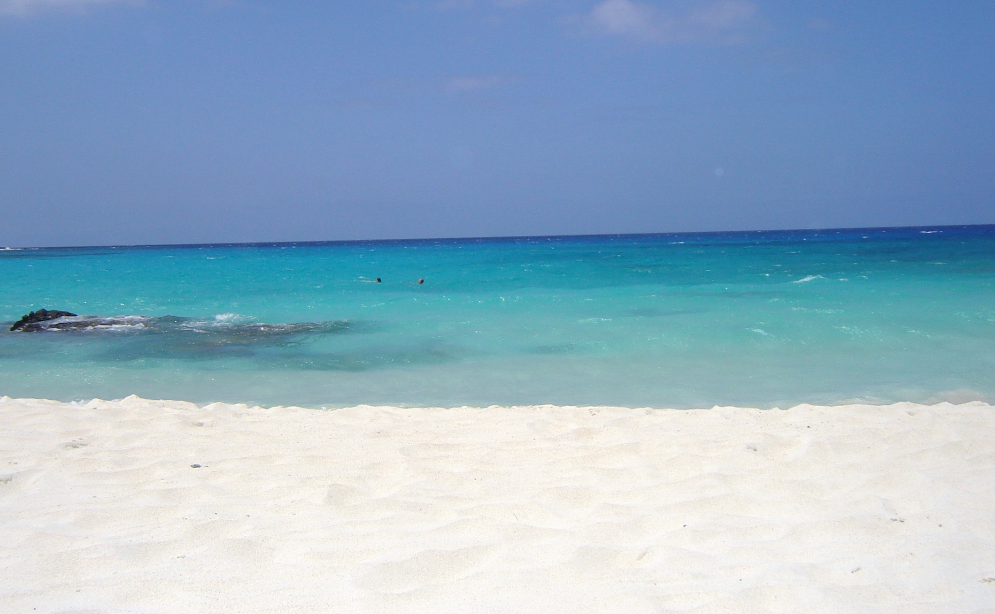

Day 1: (Kona) Take off for the adventure of a lifetime by experiencing the beauty of Hawaii. We arrive in Kona where we will be transported to a beautiful ocean front hotel.

Day 2: White sand beach and luau: The afternoon will be spent enjoying one of the world's most beautiful beaches, Mahaiula Beach in Kekaha Kai State Park. The fine white sand and the turquoise water will be sure to leave you inspired and refreshed.
As the sun sets over ‘Anaeho‘omalu Bay we will enjoy a traditional luau. Guests gather for an evening under the stars dining on culinary treasures from Hawai’i, Tahiti, New Zealand and Samoa. Dancers retell the story of the settlement of the Pacific. Displayed in its fullness is the mana (power) of the ali’i (chiefs) and how each would be forever linked to the one star that guided them.

Day 3: Pu‘uhonua o Honaunau and Kealakekua Bay: Now a national historical park, Pu‘uhonua was reconstructed by local artisans using traditional tools. One of the major features of the complex is a reconstructed temple. Fierce, wood-carved statues known as ki’i guard this oft-photographed temple, called Hale o Keawe. The original temple, built around 1650, housed the bones of at least 23 chiefs.
The group will take a 3-1/2 hour cruise to Kealakekua Bay. Here we will snorkel in the crystal clear waters of the bay. The area is teaming with an abundance of colorful fish and other marine life and contains the 27’ high Captain Cook Monument.

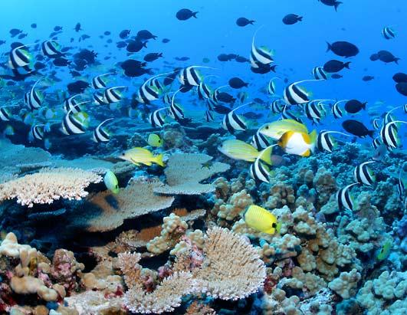

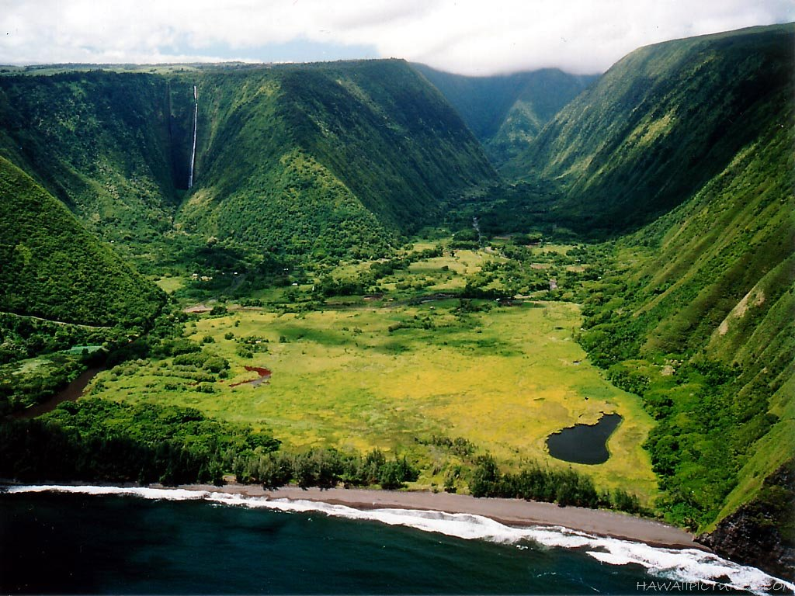

Day 4: Waipi'o Valley. Today we will journey through a lush tropical paradise of jungle trails, streams, magnificent waterfalls and incredible vistas. The Valley has a variety of historical and spiritual places to discover and experience.

In late afternoon, we will head towards Hilo and stop at Akaka Falls, a towering waterfall that plummets 442 feet. We will also drive along a 4 mile stretch called the Heritage drive loop. This lush detour features moss-laden bridges, coastal views of Onomea Bay and the Hawaii Tropical Botanical Garden on the way. This renowned botanical garden features 2,000 species of tropical plants from around the world.

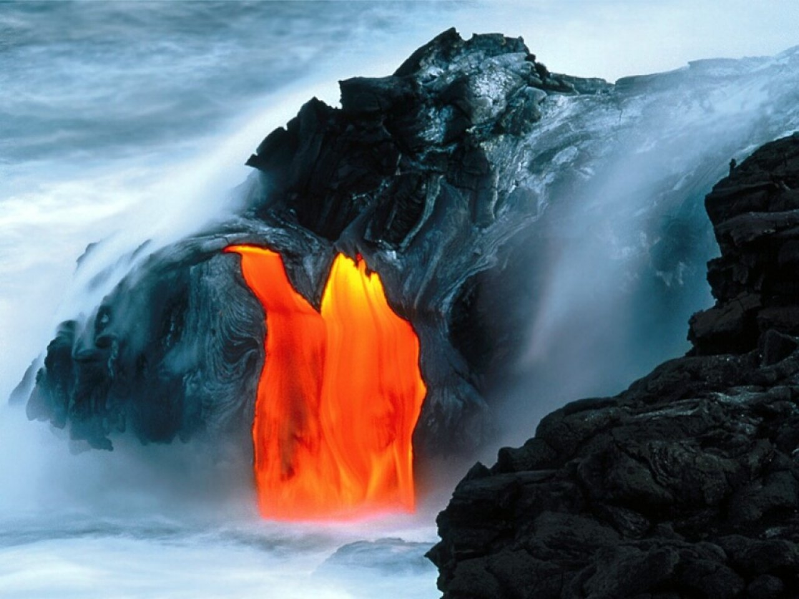
Day 5: Volcano’s National Park: This afternoon we will spend the day hiking the park. Hiking here is an awe inspiring journey through an active volcano. The breath of gasses and steam bear witness that Pele still resides here. Rich with native plant and animal life, active volcanism, and Hawaiian deities of a living culture, hikers will marvel at diverse scenic vistas, desert terrain, and lush rain forest. The Kilauea Iki trail begins on the crater's rim and descends 400 feet through the rain forest to the crater floor. We'll walk along the crater floor where you’ll literally feel the heat of the volcano as it is still steaming from its last eruption.

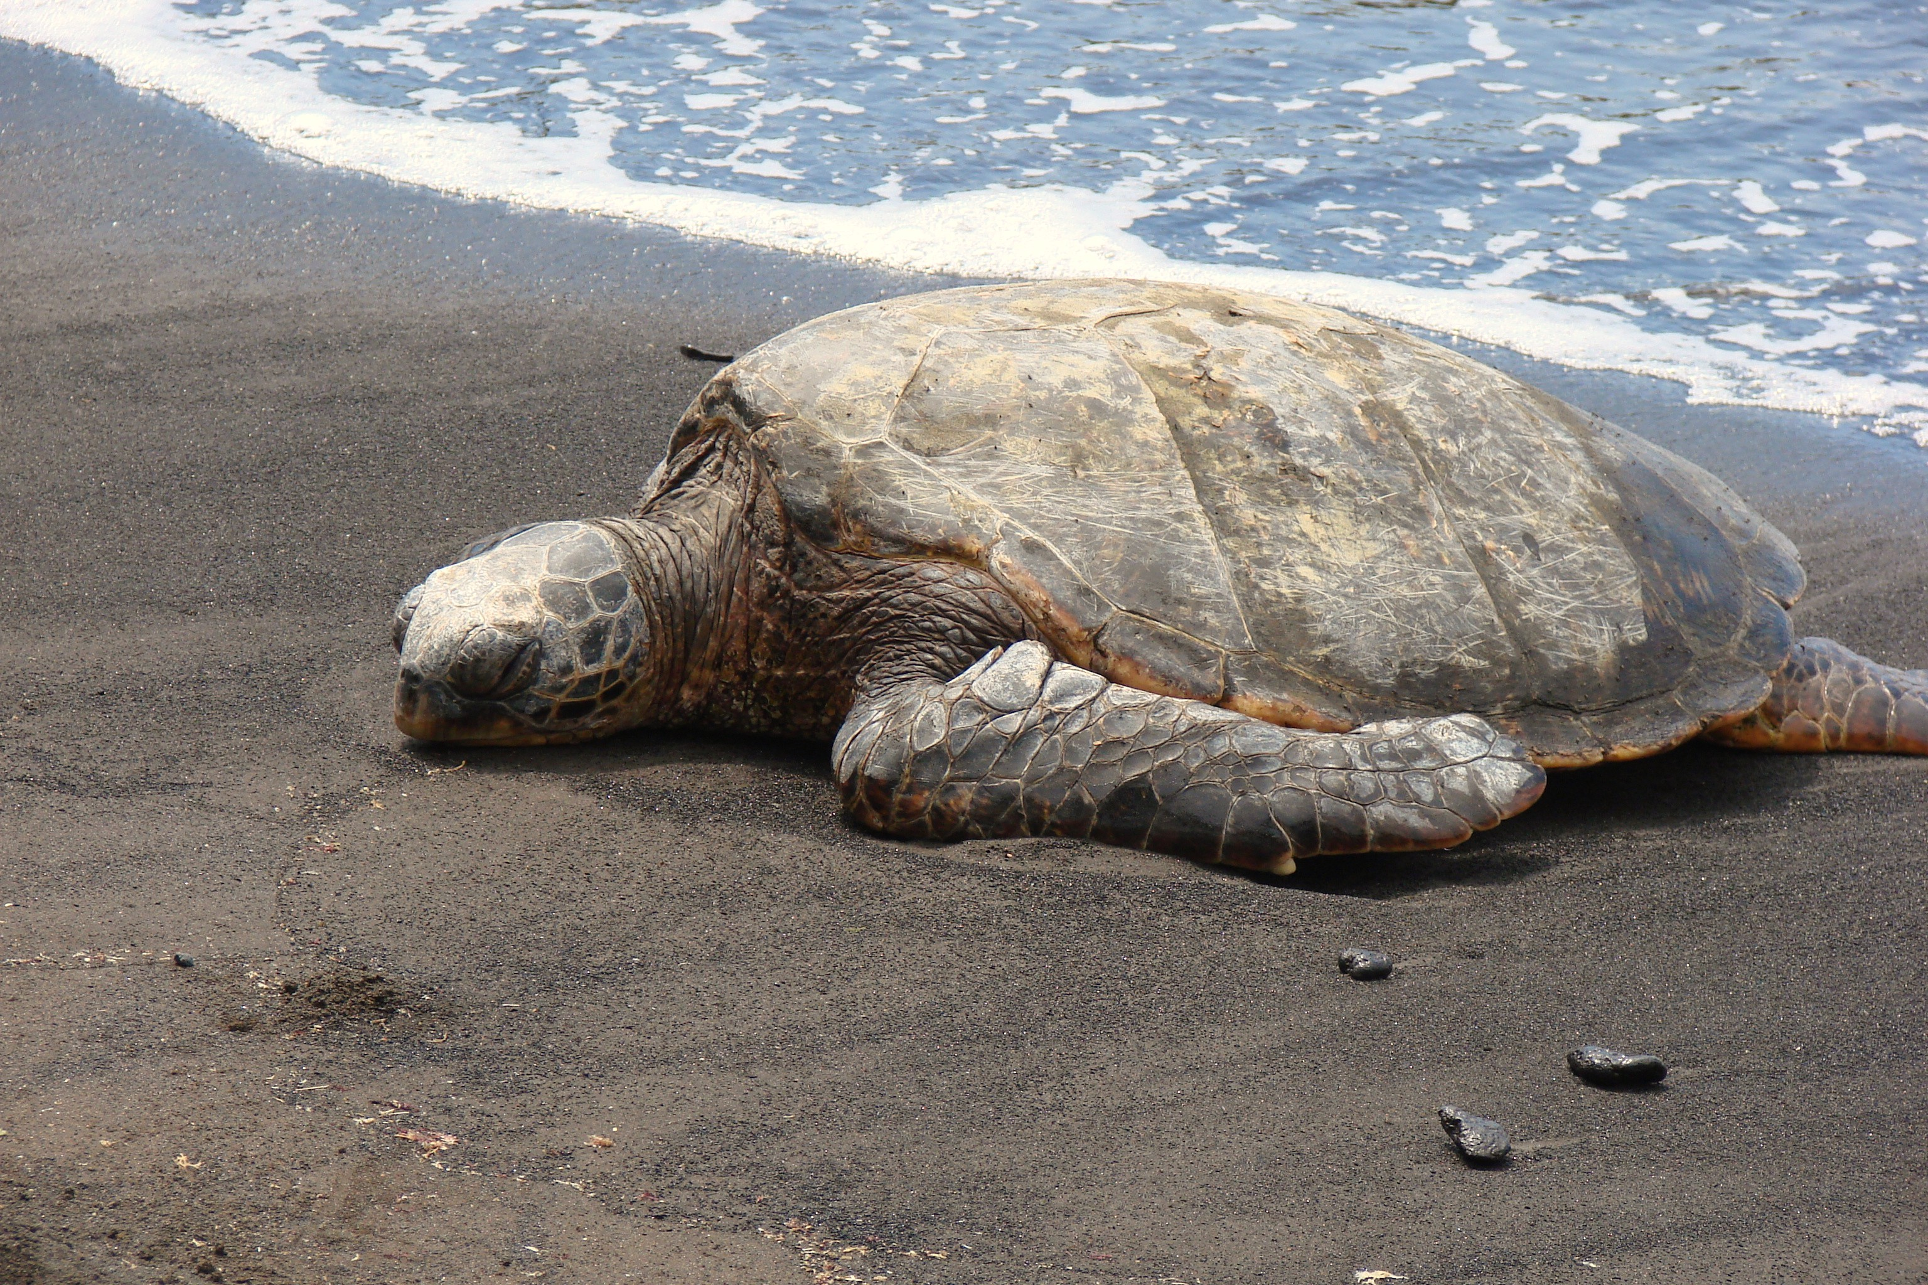

Day 6: Volcano’s National Park: Rainbow Falls is a roaring 80’waterfall with a deep cave behind it that is believed to be the home of the goddess Hina. When the cascade hits the water far below, the mists creates a rainbows. Boiling Pots, some of the river water flows beneath a level of old lava, then suddenly bubbles up as if it were boiling.
Later in the day we will continue to explore the park by driving along the Crater Rim Drive. Stops include the Kilauea Overlook, where steam is rising from the current eruption,, We will also stop at the Kilauea Iki Crater Overlook. Here you will see the cinder cone Pu’u Pua’i with an incredible view of the crater and then take a walk through the famous Thurston Lava Tube.
In the evening we will walk to the edge of the ocean to see the bright red lava flowing into the seawater.

Day 7: (Punalulu) We will start the day by stopping by the beautiful black sand beach. This beach is often visited by sea turtles laying eggs or just resting on the beach.

In the afternoon we will travel to the very southern tip of the U.S. We will then take an awe inspiring hike right along the coast line. At the end is a green sand beach that is surrounded by high gray cliffs to form a perfect sanctuary. Where else in the world are you going to be able to see a green sand beach?

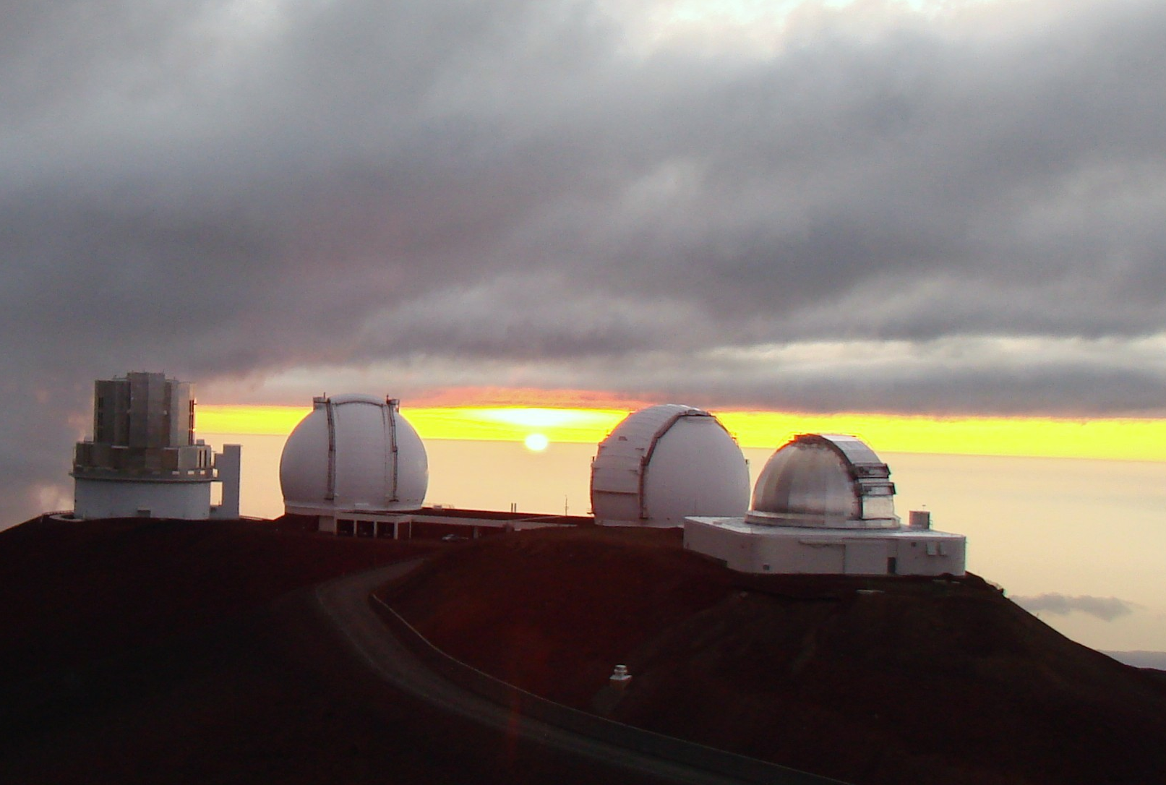

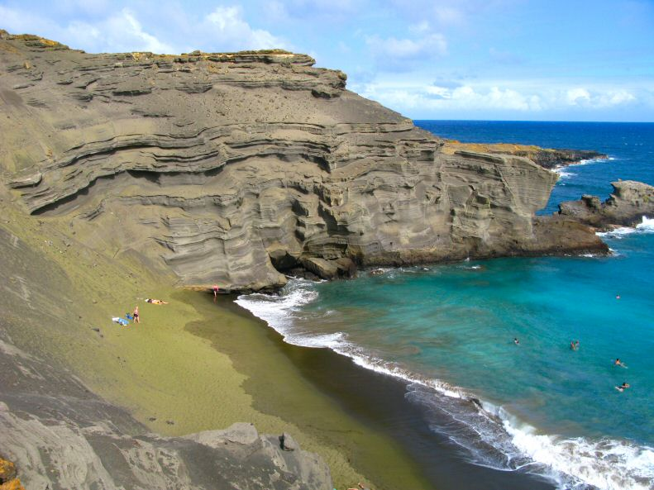

Day 8: (Mauna Kea and Option day)
Option day! You will be able to choose between 4 different activities including visiting a different beach, hiking, snorkeling or ocean cruise.

In the evening we will drive to the summit of Mauna Kea where you'll stand on top of the world's tallest mountain which rises over 31,000 feet from the ocean floor. You will have spectacular views of the horizon and of course the famous Mauna Kea sunset. After sunset there will be telescopes set up to reveal the wonders of the night sky.

There will be an informational meeting in the library at Croton High School at 7:00PM on Tuesday, June 5th.
You will receive more information on the specifics of this exciting opportunity and have the chance to ask questions. Students and parents should both attend. If you are unable to attend and would like to go on the trip, please contact Mike Mahoney at eduventures@hotmail.com.
Day 9: (Departure) Our last day will be spent souvenir shopping, snorkeling and swimming around the beachfront. Later in the day we will begin our journey home, taking memories to share with our families.

